Nabokov, Vladimir (НАБОКОВ, ВЛАДИМИР) (1899-1977)

Vladimir Nabokov was one of the leading novelists of the 20th century. He was born in St. Petersburg, Russia in 1899, but spent most of his life abroad after his family was forced to emigrate in the wake of the Bolshevik revolution of 1917. He first composed novels in Russian while living in Berlin and Paris, but switched to English when he moved to the United States in 1940. His novel entitled Lolita (1955) was immensely successful. Although he had been an American citizen since 1945, he came back to Europe in 1961, and lived in Montreux, Switzerland, where he died in 1977.

Timeline of Life and Most Famous Works Published During Lifetime
1899: born in Saint-Petersburg
1919: leaves Russia with his family and begins his studies in Cambridge
1922: joins his family in Berlin. His father is assassinated
1925: marries Vera Evseyevna Slonim
1926: Mashenka (Mary), his first novel in Russian, is published
1934: his son, Dmitri, is born
1937: Leaves Germany for France
1937-38: Dar (The Gift), his last novel in Russian, is published
1940: moves to America.
1941: The Real Life of Sebastian Knight, his first novel in English, is published
1955: Lolita is published
1961: moves back to Europe and establishes himself in Montreux, Switzerland
1962: Pale Fire is published
1964: His four-volume translation of and commentary on Alexander Pushkin's Eugene Onegin is published
1969: Ada or Ardor is published
1974: Look at the Harlequins is published
1977: dies in Montreux

Vladimir Nabokov was born on 23 April 1899 (10 April 1899 Old-Style), in St. Petersburg, to a wealthy, aristocratic family. His childhood and youth were idyllic. He received a trilingual education, and from a very early age he could read and speak English and French (which were to play a prominent part in his artistic career) alongside his native Russian. These halcyon pre-revolutionary years saw the birth of his passion for entomology, reading, and writing.
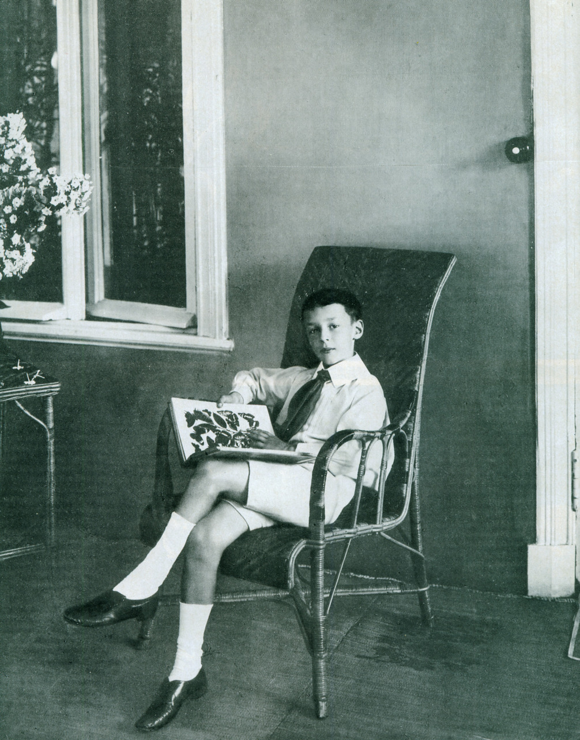
The Bolshevik revolution brought this golden era to a brutal stop. In February 1917, the Nabokovs had to leave their St. Petersburg house, and first sought refuge in Crimea, hoping that their exile would be a short one. But the evacuation of Crimea in 1919 led the family to move, first to England, then to Berlin, where Vladimir joined his relatives in 1922 after studying Slavic and Romance languages for three years at Trinity College, Cambridge. His first months in Berlin were marked by two major events in his personal life. In March 1922 his father was shot dead during a political rally, and in May 1923, he met Vera Evseyevna Slonim whom he married in April 1925. It is against this background that he began his literary career under the pseudonym of “Sirin.” He published poems and articles written in his native Russian, as well as literary translations from the French or the English in a number of émigré journals in Berlin and Paris such as Sovremmenye Zapiski and Rul’. But success really came with the publication of his first novels: Mashenka (Mary, 1926), Zashchita Luzhina (The Defense, 1930), Camera Obscura (Laughter in the Dark, 1932), Otchayanie (Despair, 1934) and Dar (The Gift, 1937). The Gift is the last novel Nabokov ever composed in Russian and arguably his best effort in his native language. In this künstlerroman where the protagonist, Fyodor Godunov-Cherdyntsev, a young Russian émigré, develops his gift as a writer, Nabokov brings together a colourful depiction of the Russian diaspora in the 1920s, a poignant evocation of his hero’s Russian youth and the biography of Nikolai Chernyshevsky, a 19th-century Russian revolutionary democrat, materialist philosopher and critic.
Photo of young Nabokov, 1907
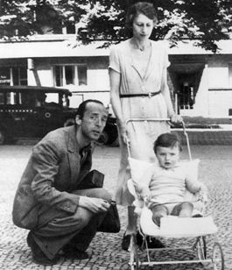
In 1937, the rise of Nazism prompted Nabokov to leave Germany for France where he published, in French, in La Nouvelle Revue Française, a long study of Pushkin entitled “Pouchkine, ou le vrai et le vraisemblable”. Yet in May, 1940, the Second World War and the looming German invasion forced the Nabokovs, now a family of three after the birth of their son Dmitri in 1934, to seek refuge in America. This new exile led to Nabokov’s most momentous literary move: he decided to relinquish his native Russian and adopt the language of his new country. He did not arrive in America empty-handed: he had spent his final years in France writing his first novel in English, The Real Life of Sebastian Knight, which was published in May 1941. In October 1940, he met Edmund Wilson, who was to become a close friend (until their falling out, twenty years later) and would introduce him to American publishers. During his American years, Nabokov supported his family by working for some time as the curator of lepidoptery at Harvard University’s Museum of Comparative Zoology (his career as a entomologist was almost as rich and distinguished as his career as a writer), and by teaching Russian and European literature at Wellesley College and Cornell University.
Nabokov, his wife Vera and son Dmitri, 1935
Nabokov butterfly hunting in Switzerland, 1966
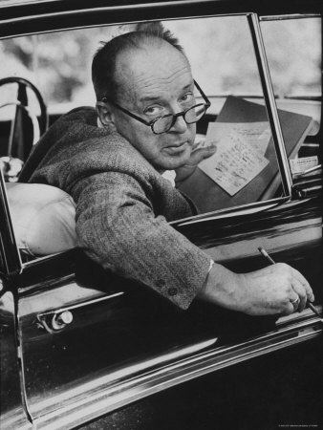
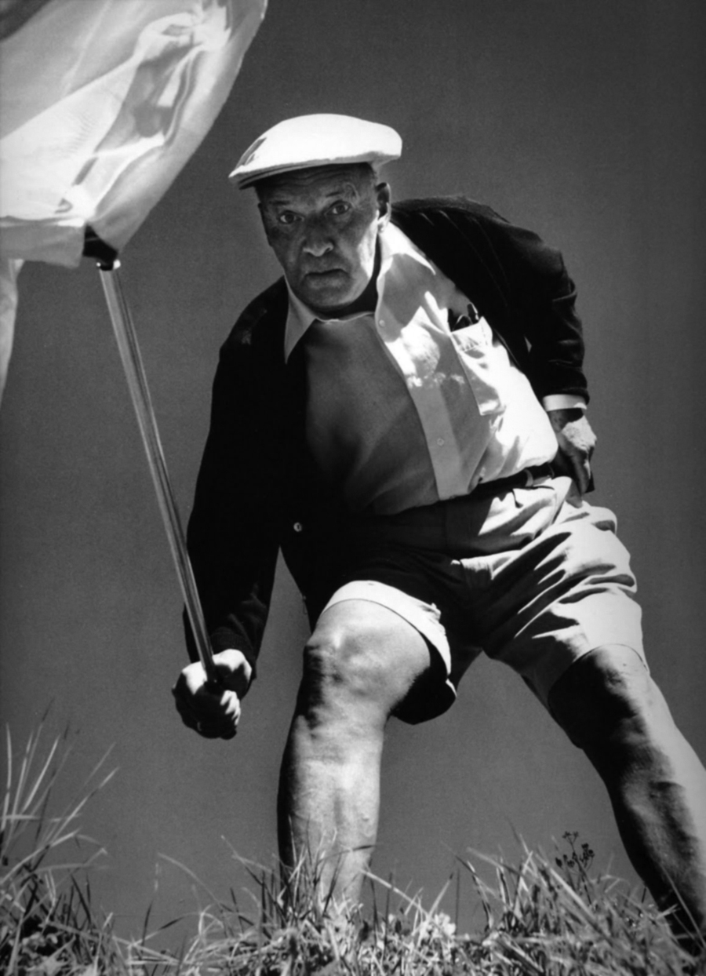
This was the context in which Lolita came to life and “exploded”. The novel, which was composed largely while travelling on the butterfly-collection trips in the western United States that Nabokov undertook every summer, was initially published in France (but in its original English version) by Olympia Press in 1955, and only appeared in the United States three years later, after a protracted legal battle. The book topped the best-seller lists and Nabokov rose to worldwide fame, although this notoriety had to do, more often than not, with the huge controversy that the novel generated. Its plot is admittedly risqué as the protagonist tells the story of his obsession and sexual relationship with a 12-year-old girl nicknamed Lolita, but reducing the novel to this simplistic line is clearly unfair, for Lolita is first and foremost a stylistic masterpiece, which completes Nabokov’s literary metamorphosis into an American writer. In 1962, the novel was turned into a movie directed by Stanley Kubrick whose screenplay was written by Nabokov himself.
Lolita, whose American début was preceded chronologically by the publication of Pnin (1957), remains the turning point in Nabokov’s literary career. Its immense success, and the financial benefits that ensued, made it possible for Nabokov to interrupt his academic career to concentrate exclusively on his writing and ponder his move back to Europe. In 1961, Nabokov and his wife settled in Montreux (Switzerland) where they occupied a suite at the Palace Hôtel.
Nabokov working on Lolita while on a butterfly collection trip
The Montreux retreat was not synonymous with retirement. On the contrary, the 1960s were a particularly active period for Nabokov. In 1962, he published Pale Fire, one of the most brilliant novels ever written. It consists of a 999-line poem by John Shade and its commentary by an academic named Charles Kinbote, followed by an Index. Its narrative structure is so complex that to this day, despite the critics’ in-depth investigations, it is still impossible to establish clearly the identity of the narrator(s).
While composing Pale Fire Nabokov was also pursuing another major quest: always a great admirer of Pushkin, he wanted to produce an annotated translation of his novel in verse, Eugene Onegin. The four-volume work (one volume for the translation itself and three volumes of notes) appeared in 1964. In 1966, Nabokov published Speak, Memory, whose subtitle, ‘an autobiography revisited’, indicates that it was the revised version of a text originally composed in English under the title Conclusive Evidence (1951), then rewritten in Russian as Drugie Berega (1954).
The autobiography preceded, Ada or Ardor (1969), yet another stunning masterpiece. Ada is a family chronicle recounting the lifelong love story between Van and his sister, Ada. The story covers a whole century and takes place in a fictional world, Antiterra, whose geography, although reminiscent of our earth, creates a subtle feeling of estrangement in the reader. This novel unites Nabokov’s artistic worlds in a perfect synthesis: while it frequently refers to the classics of Russian (and more largely European) literature, it is also a striking demonstration of his ability to fashion his own artistic idiom and map out his America.
After Ada, Nabokov transitions into the final phase of his career. The last novel published in his lifetime was Look At the Harlequins! (1974), a fictional autobiography narrated by Vadim Vadimovich N., a Russian-American writer with remarkable biographical likenesses to Nabokov himself.
Nabokov died in 1977 while composing The Original of Laura. He expressed the wish that the manuscript be destroyed if he could not complete it. Yet in 2009, after years of hesitation, Dmitri Nabokov, his son, decided to publish the unfinished novel – a manuscript consisting of 138 index cards.

Major Works
Novels
Mashenka (Mary) [1926]
Korol’, Dama, Valet (King, Queen, Knave)[1928],
Zashchita Luzhina (The Defense) [1930]
Sogliadatai (The Eye) [1930]
Podvig (Glory) [1932]
Camera Obscura (Laughter in the Dark) [1932]
Otchayanie (Despair) [1934]
Priglashenie na kazn' (Invitation to a Beheading) [1935-1936]
Dar (The Gift) [1937]
Volshebnik (The Enchanter) [1939]

Plays
Chelovek iz SSSR (The Man from the USSR) [1927]
Izobretenie Val’sa (The Waltz Invention) [1938]

Works in English
Novels
The Real Life of Sebastian Knight [1941]
Bend Sinister [1947]
Lolita [1955]
Pnin [1957]
Pale Fire [1962]
Ada or Ardor, A Family Chronicle [1969]
Transparent Things [1972]
Look at the Harlequins [1974]
The Original of Laura [2009]

Short stories
The Stories of Vladimir Nabokov [1995]
« Natasha » [2008]

Poetry
Poems and Problems [1971]

Non fiction
Autobiography
Conclusive Evidence [1951]
Drugie Berega [1954]
Speak, Memory, an Autobiography Revisited [1966]

Interviews
Strong Opinions [1973]

Lectures
Lectures on Literature [1980]
Lectures on Russian Literature [1981]
Lectures on Don Quixote [1983]

Letters
Selected Letters 1940-1977 [1989]
Dear Bunny, Dear Volodya, The Nabokov-Wilson Letters [2001]

Translation
Ania v strane chudes, by L. Karrol’ (Alice in Wonderland , by Lewis Carroll) [1923]
A Hero of Our Time, by Mikhail Lermontov [1958]
Eugene Onegin, A Novel in Verse by Alexandr Pushkin, Translated from the Russian, with a
commentary, by Vladimir Nabokov [1964]

References and Further Reading
Biography
BOYD, B. (1991) Vladimir Nabokov, The Russian Years, Princeton: Princeton University Press.
—— (1991) Vladimir Nabokov, The American Years, Princeton: Princeton University Press.
This two-volume biography is the most complete to date. Excellent bibliography.

Selection of critical works
ALEXANDROV, V. E. (edited by) (1995) The Garland Companion to Vladimir Nabokov, New York: Routledge. A very fine collection of studies on Nabokov’s Russian and American works by expert Nabokov scholars. Excellent bibliography.
APPEL, A. Jr. (edited by) (1970) The Annotated Lolita. A brilliantly annotated edition of Nabokov’s most popular novel.
CONNOLLY, J. W. (edited by) (2005) The Cambridge Companion to Nabokov, Cambridge: Cambridge University Press. Another great collection of studies. Very readable.

Source URLs
Figure 1.
Young Vladimir Nabokov, 1907
http://24.media.tumblr.com/tumblr_lsb6m82tb81r3sn0vo1_1280.jpg

Figure 2.
Vladimir Nabokov, his wife Vera and their son Dmitri, Berlin, 1935
http://artcorusse.org/wp-content/uploads/2012/03/nabokovs.jpg

Figure 3. Nabokov butterfly hunting in Switzerland. Ph. Halsman, 1966.
http://erinzingre.files.wordpress.com/2012/07/2012-07-25_vladimirnabokov.jpg

Figure 4.
Nabokov working on Lolita during a butterfly-collection trip.
http://cache2.artprintimages.com/lrg/27/2781/UMOTD00Z.jpg

Footage
Nabokov discusses Lolita on Close Up.
Part 1 : http://www.youtube.com/watch?v=Ldpj_5JNFoA
Part 2 : http://www.youtube.com/watch?v=0-wcB4RPasE&feature=relmfu

